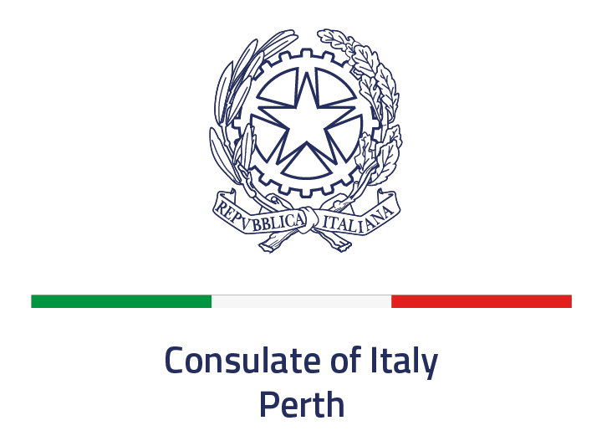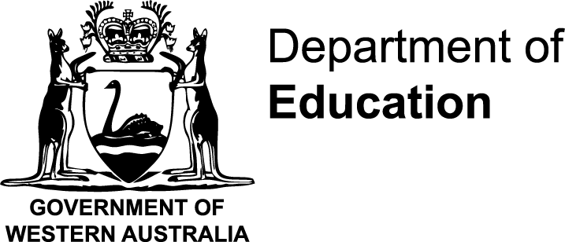

LANGUAGE ASSISTANT PROGRAM IN WESTERN AUSTRALIA

January 2026 to January 2027

SELECTION ANNOUNCEMENT

The Department of Education of Western Australia in collaboration with the Consulate of Italy in Western Australia is seeking participants for the 2026 Italian Language Assistant Program.
Participants will assist in primary and/or secondary Italian language classrooms, promoting the Italian language and culture in Western Australia in the language classroom, across learning areas and around the school. Participants will be employed by the Department of Education from 29 January 2026 to 2 February 2027 as a Level 1.1 Education Assistant (Mainstream) under the current General Agreement, this equates to $AU30.75/hour (gross).
Applications are to be emailed to perth.pa@esteri.it by 7th of May. Please note, only emailed applications to this email address will be accepted.

General requirements

Applicants must:

- be Italian citizens under the age of 30 years;
- hold a Masters degree (Laurea magistrale) in Humanities with specialization in the teaching of Italian as a foreign language (previous experience as a language assistant would be preferred);
- have proficient written and oral English skills (proven by IELTS score of at least 6.0 or equivalent);
- be available for an interview if required during the selection process;
- complete a medical check if selected;
- arrange and pay for their own travel documents (passport and visa), flights to and from Australia, health insurance, to fulfill 408 visa requirements;
- agree to be posted to any location within Western Australia.

Please include the following documents in your email application:

- Application form and signed statement of agreement;
- A valid Italian ID;
- Curriculum vitae;
- A copy of IELTS or equivalent certificate;
- A copy of education certificates and transcript;
- A short essay (max. 500 words) outlining your reasons for applying to take part in the Language Assistant Program;
- A recommendation letter (if any); and
- An Italian Police Department Criminal record check (Certificato del Casellario Giudiziale o Certificato dei Carichi Pendenti).

Successful applicants will be notified in October 2024 through the contacts provided in the application form.

ASSESSMENT GUIDELINES

Assessment criteria | Maximum Points Awarded
Exams related to teaching of Italian as a foreign language during the Masters Degree in Humanities | 15
Certificates/specialisation in teaching Italian as a foreign language (if any) | 20
Other degrees (including PhDs, if any) | 10
English proficiency level and language skills | 10
Motivation letter | 15
Previous experience as a language assistant | 20
Professional development (including international experience) | 5
Reference letter(s), if any | 5
TOTAL | 100

In the event of equal scores, the Commission will organize an online interview to rank the candidates.

2025 LANGUAGE ASSISTANT PROGRAM APPLICATION FORM

PERSONAL DETAILS

Surname
Other Names
Date of birth
Place of birth
Citizenship
Address
Email
Mobile phone
Occupation

EDUCATION

Degree
Grade
Year obtained
Thesis topic
Specialisation

Other professional learning (seminars, courses, training)

Date | Details

LANGUAGE SKILLS

English level
Other languages

WORK EXPERIENCE

Year | Employer | Position

PERSON TO BE NOTIFIED IN ITALY IN CASE OF EMERGENCY

Name
Relationship
Telephone | +39
Email

STATEMENT OF AGREEMENT

If accepted for the 2026 Language Assistant Program, I will:

- abide by the regulations of the Department of Education of Western Australia;
- agree to be posted to a regional area if required;
- actively promote Italian language and culture in Western Australian schools;
- be responsible for organising my own travel documents and arrangements;
- be responsible for my daily financial requirements (eg. accommodation, food, clothing, utilities, insurances and other necessary expenses) during the program.

I certify that the statements I have made in response to the foregoing questions are true, complete and correct to the best my knowledge.

Signature:

Date:

Please email your application to the Consulate of Italy in Western Australia by

7th of May 2025
perth.pa@esteri.it

(Please write BANDO ASSISTENTI LINGUISTICI 2026 IN THE OBJECT)

